**Super Markets Point-of-Sale System**

**Done by: Mazen Al Hakim**

**Introduction:**

With the evolution of business comes many complications to manage data between our hands to benefit from it, here technology comes to handle these issues and help us in our daily life. This project comes to help super market accountants and cashiers in their wok.

**Scope:**

My project is a Point-of-Sale system that helps its administrator in entering his products information to the stock and selling them, in addition to almost all the calculations needed by the accountant or cashier to do with respect to purchasing products from supplier, selling products to client in debit or credit, in accounting for employees.

**Diagrams:**

Database:

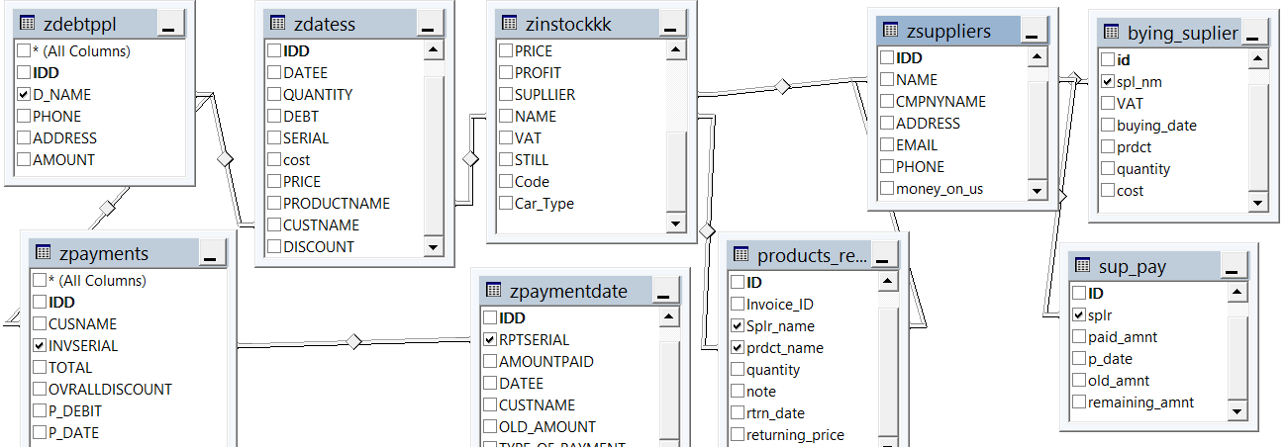

GUI:

1. Main Page:

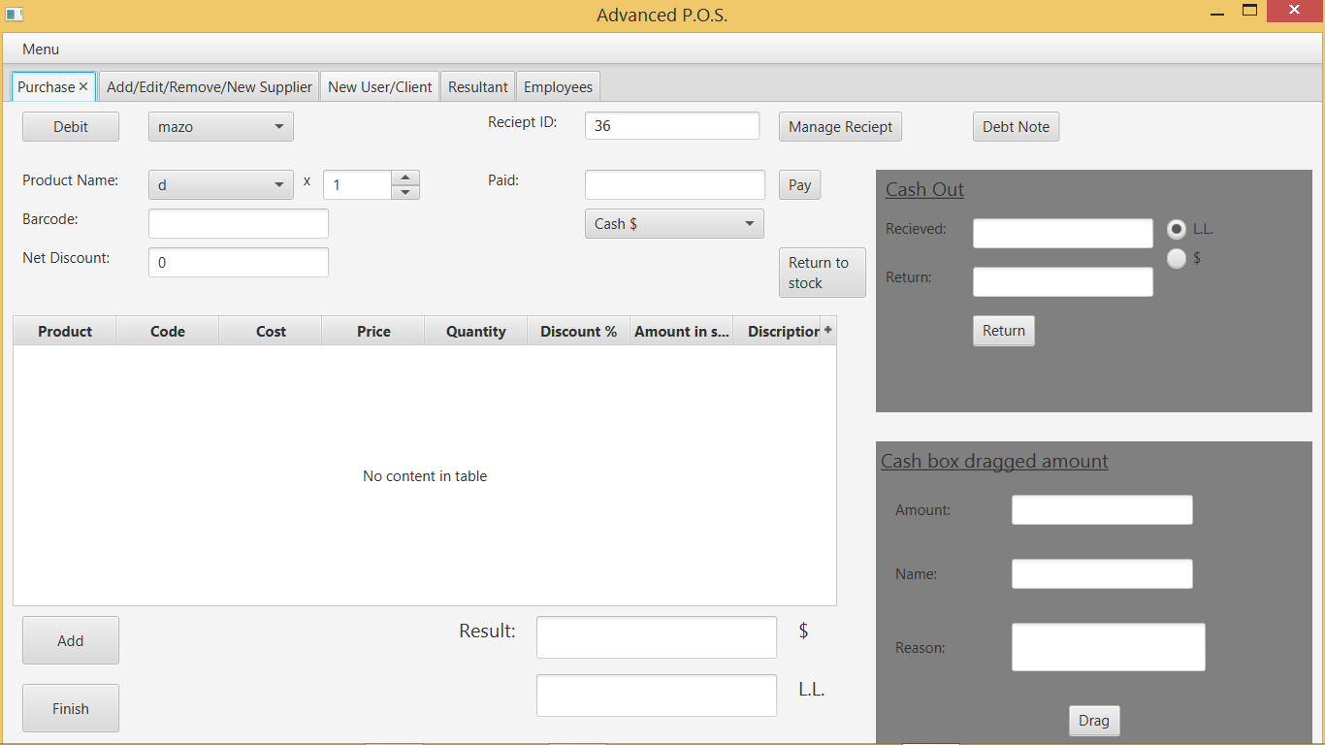

1. Debit Note:

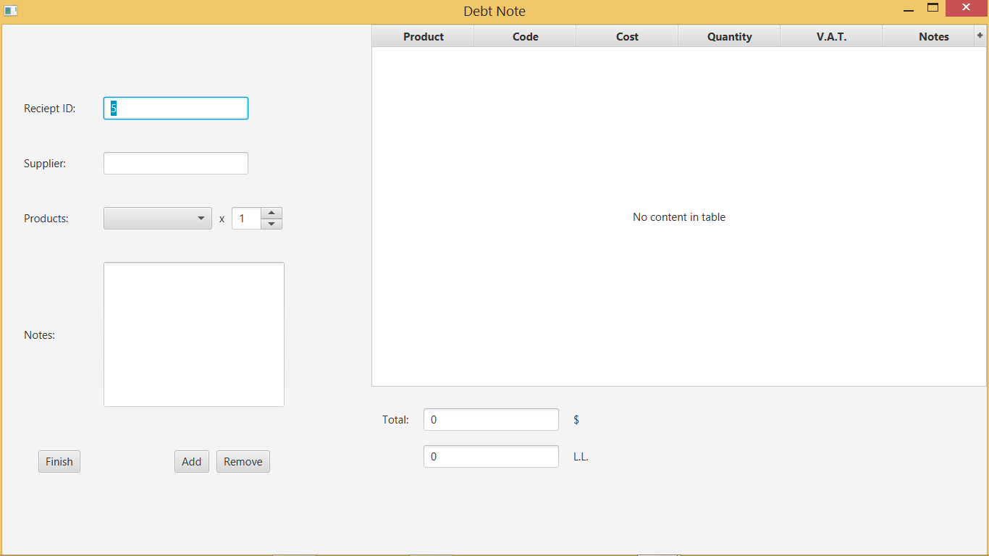

1. Manage Receipt:

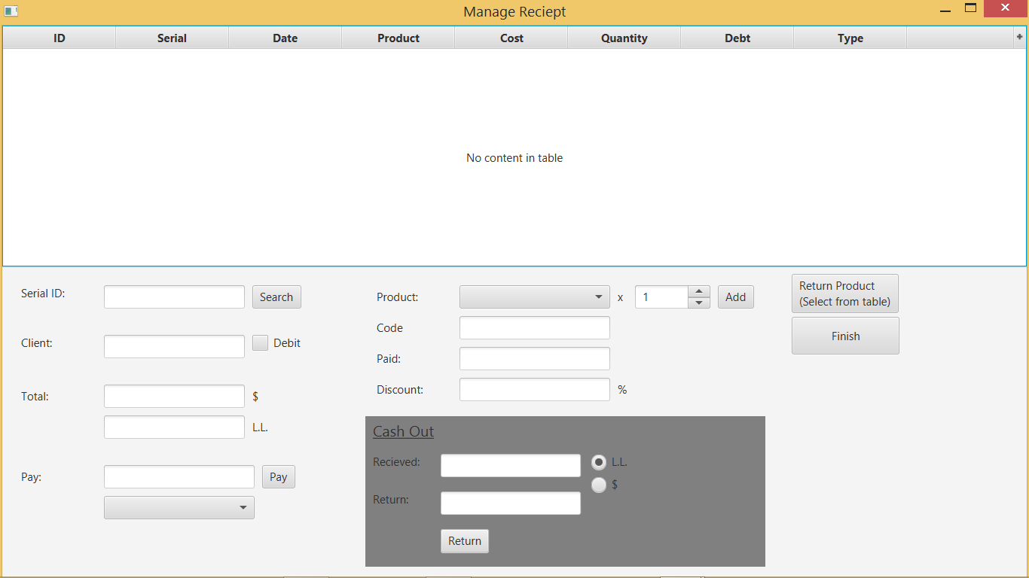

Functions and rules needed:

1. Functions for selling product:

vat = rs.getDouble("VAT");

price = rs.getDouble("PRICE")* (1 - rs.getDouble("DISCOUNT")/100);

remaining_in_stock = rs.getDouble("REMAINEDSTOCK");

cost = rs.getDouble("COST") * (1 + vat/100);

if(remaining_in_stock – quantity_sold < 0){//Alert Message

JOptionPane.showMessageDialog(null,

"you can only buy: "+remn+"\nThis product is about to finish!!\nYou must buy some more of it.","Error Message",JOptionPane.ERROR_MESSAGE);

retur

}

if(CheckBoxMenuItem.isSelected()){//Alert option

if(remaining_in_stock <= 10){//Alert

JOptionPane.showMessageDialog(null, "This product is about to finish!!\nYou must buy some more of it.", "Error Message",

JOptionPane.ERROR_MESSAGE);

}

}

remaining_in_stock -= quantity­_sold;